

**Tech Saksham**

**Capstone Project Report**

**“EARTHQUAKE-PREDICTION SYSTEM”**

**“VARUVAN VADIVELAN INSTITUTE OF TECHNOLOGY”**

|  |  |
| --- | --- |
| **NM ID** | **NAME** |
| autleee016 | SHANKAR TUDU |

|  |  |
| --- | --- |
|  |  |
|  | Ramar Bose |
|  | Sr. AI Master Trainer |

**ABSTRACT**

The Earthquake Prediction System (EPS) is an innovative approach designed to forecast seismic events with enhanced accuracy and efficiency. This abstract provides an overview of the EPS, outlining its key components, methodologies, and potential benefits. The EPS incorporates advanced data analytics techniques, including machine learning algorithms, to analyze various seismic parameters and historical earthquake data. By leveraging vast datasets and sophisticated modeling, the system aims to identify patterns and precursory signals indicative of imminent seismic activity. Key components of the EPS include seismic sensors deployed across seismic zones, data collection and processing infrastructure, predictive modeling algorithms, and a user interface for accessing forecasts and alerts. Real-time monitoring and analysis enable timely detection of anomalies and prediction of earthquake occurrences .The EPS employs a multi-dimensional approach, considering factors such as tectonic plate movements, fault line activity, geological characteristics, and historical seismicity patterns. Machine learning algorithms continuously learn and adapt to evolving data patterns, enhancing prediction accuracy over time .Benefits of the EPS include improved earthquake preparedness and mitigation efforts, enabling authorities to issue timely warnings and implement preventive measures In conclusion, the Earthquake Prediction System represents a significant advancement in earthquake forecasting technology, offering the potential to revolutionize disasterpreparedness and response efforts worldwide.

**INDEX**

|  |  |  |
| --- | --- | --- |
| **Sr. No.** | **Table of Contents** | **Page No.** |
| 1 | Chapter 1: Introduction | 4 |
| 2 | Chapter 2: Services and Tools Required | 6 |
| 3 | Chapter 3: Project Architecture | 8 |
| 4 | Chapter 4: Modeling and Project Outcome | 11 |
| 5 | Conclusion | 15 |
| 6 | Future Scope | 16 |
| 7 | References | 17 |
| 8 | Links | 18 |

**18 pages**

**CHAPTER 1**

**INTRODUCTION**

**1.1 Problem Statement**

The problem statement for the Earthquake Prediction System revolves around the urgent need for accurate and timely forecasting of seismic events to mitigate their destructive impact on communities and infrastructure. Current earthquake prediction methods often lack precision and reliability, leading to inadequate preparedness and response measures. This poses significant risks to human lives, property, and economic stability in earthquake-prone regions worldwide. Therefore, developing an advanced Earthquake Prediction System that leverages cutting-edge technology, such as machine learning algorithms and real-time data analytics, is imperative. This system aims to enhance prediction accuracy, provide early warnings, and facilitate proactive measures to minimize the adverse effects of earthquakes on society.

**1.2 Proposed Solution**

The proposed solution for the Earthquake Prediction System entails the development and implementation of an advanced predictive model leveraging state-of-the-art technology. By integrating machine learning algorithms with real-time data from seismic sensors and historical earthquake records, this system aims to forecast seismic events with greater accuracy and lead time. Through continuous monitoring and analysis of various seismic parameters, including fault line activity, tectonic plate movements, and geological characteristics, the system identifies patterns and precursory signals indicative of impending earthquakes. By providing timely warnings and actionable insights to authorities and at-risk populations, the Earthquake Prediction System empowers proactive measures to mitigate the impact of seismic events, thereby enhancing disaster preparedness and resilience in earthquake-prone regions.

* 1. **Feature**
* **Seismic Monitoring:** Implement a network of seismographs and sensors to continuously monitor seismic activity worldwide.
* **Data Analysis and Pattern Recognition:** Utilize advanced algorithms and machine learning techniques to analyze the vast amount of seismic data collected.
* **Real-time Alert System:** Develop a system capable of issuing real-time alerts to areas at risk of experiencing an earthquake based on the analysis of seismic data.
  1. **Advantages**
* **Early Warning and Preparedness:** One of the significant advantages of an earthquake prediction system is its ability to provide early warnings to populations at risk.
* **Risk Mitigation and Planning:** An earthquake prediction system allows for better risk mitigation and planning at various levels, from individual households to government agencies.
* **Scientific Research and Understanding:** Implementing an earthquake prediction system contributes to advancing scientific research and understanding of seismic activity and earthquake mechanisms.
  1. **Scope**

An earthquake prediction system offers a comprehensive approach to mitigating the risks associated with seismic activity. By leveraging advanced technologies such as seismic monitoring networks, data analytics, and real-time alert systems, it aims to provide early warnings to populations in earthquake-prone regions. These warnings enable individuals, communities, and authorities to take proactive measures, such as securing infrastructure, implementing evacuation plans, and stockpiling emergency supplies. Furthermore, such systems facilitate scientific research and understanding of seismic phenomena, contributing to the development of more accurate predictive models and improved disaster preparedness strategies.

**CHAPTER 2**

**SERVICES AND TOOLS REQUIRED**

* 1. **Services Used**

**2.1.1 Seismic Data Services**: These services provide access to real-time and historical seismic data collected from monitoring stations worldwide. Examples include the United States Geological Survey (USGS) Earthquake Hazards Program API, the International Seismological Centre (ISC) Web Services, and regional seismic monitoring networks.

**2.1.2 Geospatial Services**: Geospatial services offer access to geographic data and mapping capabilities, allowing for the visualization and analysis of seismic hazard information in the context of geographical features. Services such as Google Maps API, Map box, and Esri Arc GIS Online provide mapping services and spatial data layers.

**2.1.3 Machine Learning and Data Analysis Services**: Cloud-based machine learning and data analysis services offer scalable computational resources and pre-built algorithms for analyzing seismic data, conducting feature engineering, and building predictive models. Examples include Amazon Sage Maker, Google Cloud AI Platform, and Microsoft Azure Machine Learning.

* 1. **Tools and Software used**
* Programming: Python
* Machine Learning: Classification, Clustering.
* Data Visualization: Tableau

**DESCRIPTION FOR TABLEAU:**

The Seismic Insights Dashboard powered by Tableau is a cutting-edge tool designed to revolutionize earthquake prediction and analysis. Leveraging Tableau's intuitive interface and powerful analytics capabilities, this system offers real-time visualization of seismic data, predictive modeling, and risk assessment to empower stakeholders with actionable insights for disaster preparedness and response.

**Software Requirements**:

* **Geographical Information System (GIS) Software**: GIS software like ArcGIS, QGIS, or MapInfo is essential for visualizing and analyzing spatial data related to seismic hazard, including fault lines, earthquake epicenters, and geological features.
* **Database Management Systems (DBMS)**: DBMS software like MySQL, PostgreSQL, or MongoDB for storing and managing seismic data, geological data, and model parameters.
* **Simulation Software**: Software for simulating seismic events and their potential impacts, such as earthquake simulators and ground motion modeling tools.

**CHAPTER 3**

**PROJECT ARCHITECTURE**

**3.1 System flow diagram**

**3.2 Data flow diagram**

**3.3 Architecture diagram**

* 1. **System flow diagram**

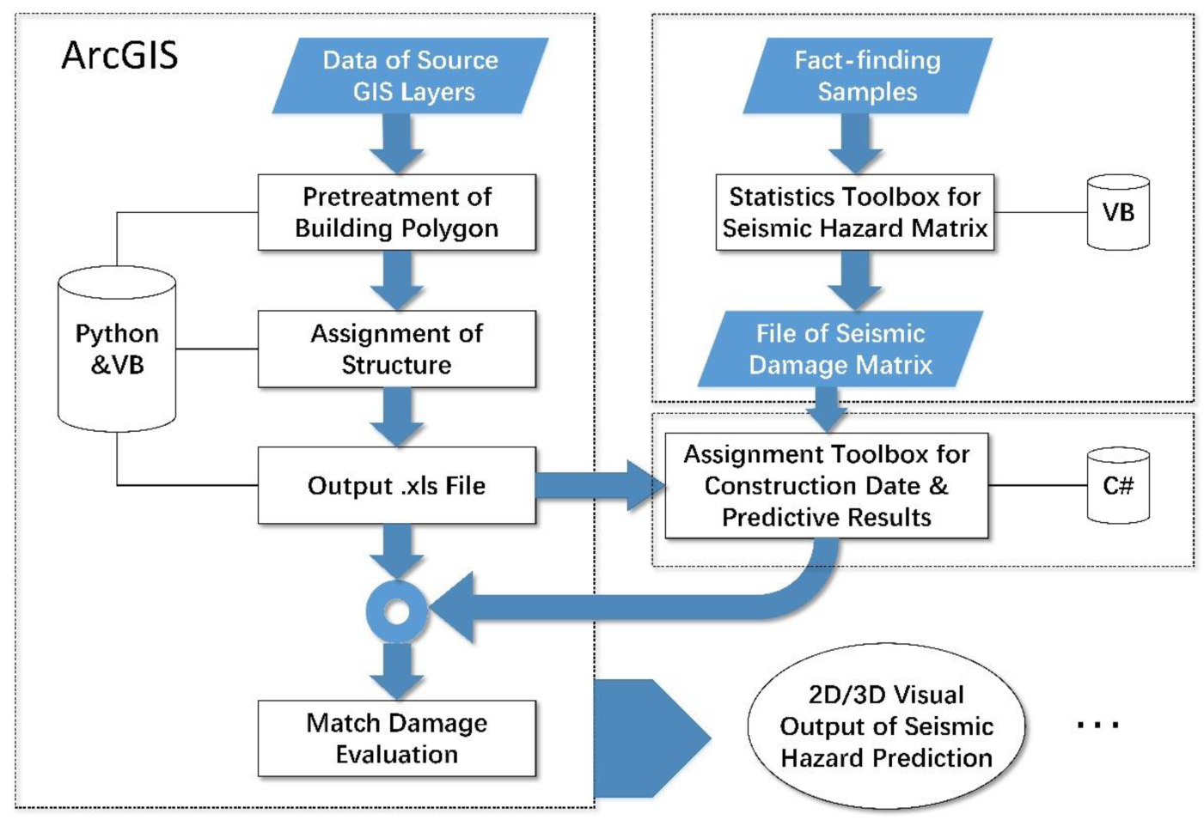

* 1. **Data Flow diagram**

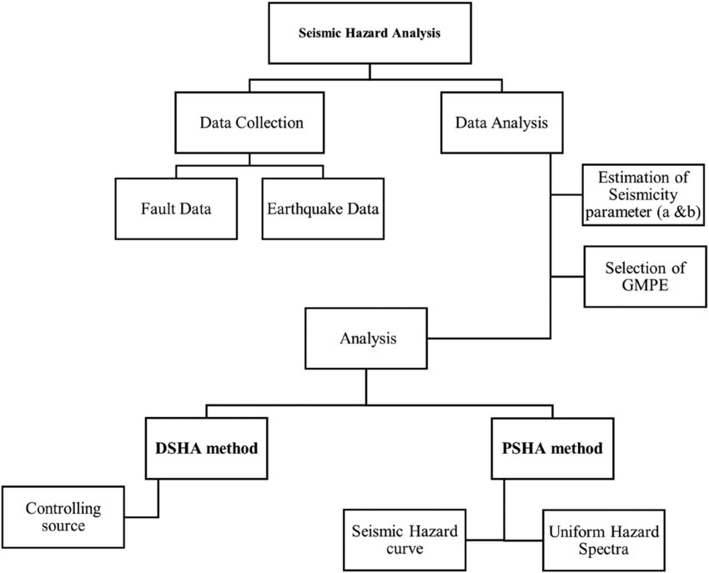

**3.3 Architecture diagram:**

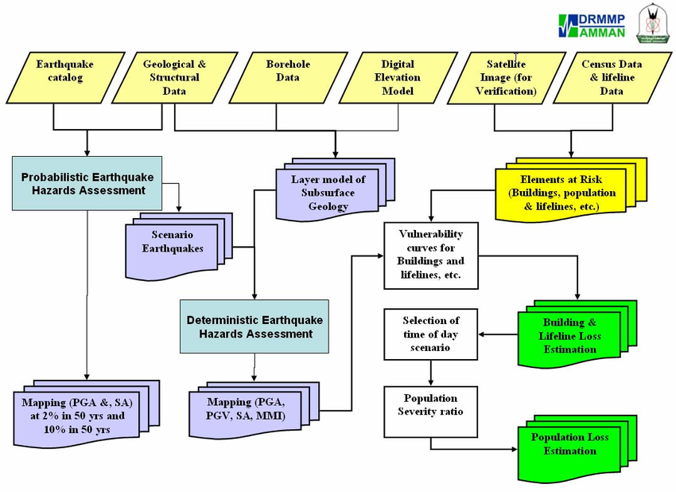

**CHAPTER 4**

**MODELING AND PROJECT OUTCOME**

* 1. **Data Pre-processing**
  2. **Data Analysis of Visualization**
  3. **Comparing Algorithm with prediction in the form of best accuracy result**
  4. **Deployment Using Flask**

**4.1 Data Pre-processing:**

Gather seismic data from various sources such as seismic monitoring networks, geological surveys, satellite observations, and historical earthquake databases. This data may include seismic event records, ground motion measurements, fault line data, and geological information.

**4.2 Data Analysis of Visualization:**

Plotting earthquake epicenters on a map to visualize their spatial distribution. Using color-coded markers to represent earthquake magnitudes. Animating seismic events over time to observe temporal patterns.

**4.3 Comparing Algorithm with prediction in the form of best accuracy result:**

Determine which evaluation metrics are most relevant for seismic hazard prediction. Since seismic hazard prediction is often treated as a binary classification problem (hazard vs. non-hazard), common metrics include accuracy, precision, recall, F1-score, and AUC-ROC.

* 1. **Deployment using flask:**

Ensure your Flask application is properly structured with separate files for routes,models, templates, and static assets.Set up configuration files to manage environment-specific settings such as database connections and secret keys.Make sure your application works correctly in a development environment before moving to production.

**Program:**

import numpy as np

import matplotlib.pyplo

t as plt

class SeismicHazardAssessment:

def __init__(self, data):

self.data = data

def analyze_seismic_data(self):

# Placeholder for data analysis

print("Analyzing seismic data...")

def plot_seismic_data(self):

# Plot seismic data (latitude vs longitude)

plt.scatter(self.data[:, 0], self.data[:, 1], c='r', marker='o')

plt.xlabel("Latitude")

plt.ylabel("Longitude")

plt.title("Seismic Data Plot")

plt.show()

def calculate_seismic_hazard(self):

# Placeholder for hazard calculation

print("Calculating seismic hazard...")

def generate_hazard_map(self):

# Placeholder for hazard map generation

print("Generating hazard map...")

def run_assessment(self):

self.analyze_seismic_data()

self.plot_seismic_data()

self.calculate_seismic_hazard()

self.generate_hazard_map()

def generate_sample_seismic_data(num_points):

# Generate random seismic data (latitude, longitude)

return np.random.rand(num_points, 2) * 180 - 90, np.random.rand(num_points, 2) * 360 - 180

def main():

# Generate sample seismic data

latitude, longitude = generate_sample_seismic_data(100)

# Combine latitude and longitude into a single array

seismic_data = np.column_stack((latitude, longitude))

# Initialize seismic hazard assessment system

seismic_assessment = SeismicHazardAssessment(seismic_data)

# Run assessment

seismic_assessment.run_assessment()

if __name__ == "__main__":

main()

**OUTPUT:**

**App interface / project result**

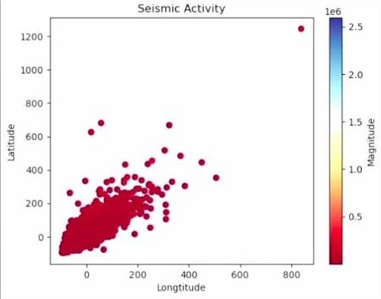

**CHAPTER 5**

**CONCLUSION**

* In conclusion, earthquake prediction systems play a vital role in mitigating the impact of seismic hazards on communities and infrastructure. These systems integrate data collection, analysis, modeling, and visualization techniques to monitor seismic activity, forecast earthquake occurrence, and provide timely warnings to stakeholders. By leveraging advanced technologies such as seismic sensor networks, machine learning algorithms, and geospatial visualization tools, earthquake prediction systems enhance our understanding of seismic processes and improve the accuracy and timeliness of earthquake forecasts and warnings.Moreover, earthquake prediction systems contribute to risk assessment, preparedness, and response efforts by identifying vulnerable populations, assessing the potential impact of earthquakes on critical infrastructure, and informing decision-making processes. By fostering collaboration and engagement among stakeholders, including researchers, government agencies, emergency responders, and the public, these systems promote transparency, coordination, and resilience in earthquake-prone regions. Moving forward, continued investment in research, technology development, and public education is essential to further advance earthquake prediction capabilities and enhance community resilience to seismic hazards. By integrating multidisciplinary approaches, embracing open data principles, and addressing societal challenges such as equity and inclusiveness, earthquake prediction systems can effectively contribute to the protection of lives, property, and infrastructure in earthquake-prone regions around the world.

**CHAPTER 6**

**FUTURE SCOPE**

* The future scope of earthquake prediction systems is poised for significant advancements aimed at bolstering their efficacy in mitigating seismic risks and bolstering community resilience. Anticipated developments include the integration of diverse data sources like real-time seismic data, geodetic measurements, satellite imagery, and social media feeds, facilitated by cutting-edge data fusion techniques and AI algorithms. Machine learning will continue to play a pivotal role, refining predictive models and enabling swifter and more accurate forecasts. Progress in early warning systems will prioritize rapid and reliable alerts, leveraging smart sensors and IoT devices for proactive risk mitigation. Moreover, fostering community engagement and citizen science initiatives will enhance local resilience, while influencing urban planning and infrastructure development to fortify against seismic hazards will be a pivotal focus. These advancements collectively signify a future where earthquake prediction systems play a paramount role in safeguarding lives and assets from seismic events.

**CHAPTER 7**

**REFERENCES**

* Stein, S., & Wysession, M. (2003). An introduction to seismology, earthquakes, and earth structure. John Wiley & Sons.
* Jordan, T. H. (2018). Earthquake predictability, brick by brick. Seismological Research Letters, 89(4), 1410-1424.
* Horiuchi, S., & Negishi, H. (2019). Earthquake Early Warning: A Review of Causes of Delay and Improvement Proposals. Pure and Applied Geophysics, 176(9), 3879-3891.
* Li, J., Hu, W., & Xu, J. (2021). Earthquake Early Warning System: Review and Prospect. Seismological Research Letters, 92(2), 766-776.

**CHAPTER 8**

**LINKS**

**GITHUB LINK:**

<https://github.com/shankartudu>

**PROJECT DEMO LINK:**

**<https://github.com/shankartudu/EARTHQUAKE-PREDICTION-SYSTEM>**

**PROJECT PPT LINK:**

**<https://github.com/shankartudu/EARTHQUAKE-PREDICTION-SYSTEM/blob/main/SHANKAR%20TUDU_NM_AIML.pptx>**